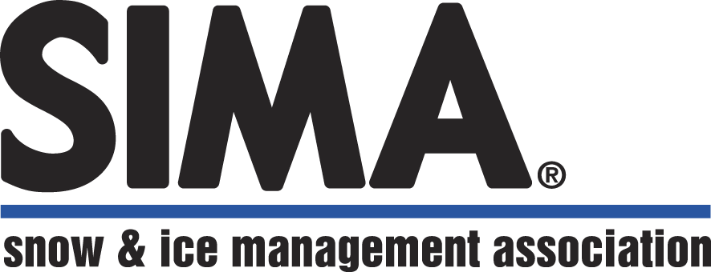 | 10140 N. Port Washington Road  Mequon, WI 53092  P: 414-375-1940 | F: 414-375-1945  www.sima.org

FOR IMMEDIATE RELEASE
CONTACT: SIMA CEO Martin Tirado, 414-375-1940

Mequon, WI (July 26, 2021) – MSNW Group, LLC of Ferndale, WA recently received national recognition from the Snow & Ice Management Association (SIMA) as part of the 24th Annual Snow & Ice Symposium awards program.

The company was honored as a Best Place to Work in Snow & Ice. The award recognizes companies in the snow and ice industry that are focused on being a great place to work and promoting the industry as one in which people can build successful and rewarding careers. Applicants were judged on demonstrated success in training; professional development and support; company culture; managerial effectiveness; personal engagement; team dynamics; and trust in leadership.

MSNW Group, LLC also received a SIMA Safety Award, presented to companies that maintained exceptional safety standards to protect their employees, clients and the public during the 2020-21 snow season.

In addition to the company awards, Branch Administrator Amy DeWitt was also chosen as an Alan Steiman Symposium Scholarship recipient. The scholarship was created in recognition of longtime SIMA member, mentor and friend Alan Steiman, CSP, and is awarded each year to a first-time Symposium attendee that embodies Steiman’s spirit of camaraderie and his belief that education is essential to success in the snow and ice management industry.

“SIMA is proud to present the snow & ice industry awards to deserving companies,” says SIMA CEO Martin Tirado, CAE. “The awards recognize companies that are dedicated to the snow and ice industry through safety, successful business practices, professionalism, and more.”

ABOUT SIMA

The Snow & Ice Management Association is a North American trade association for snow & ice industry professionals based in Mequon, WI. Learn more at www.sima.org.

